PROJECT TITLE: KITCHEN VISION: SMART PANTRY & RECIPE AI SYSTEM
PROJECT TEAM ID: SWTID-2026-2556
TEAM LEADER : ANUSHA M
TEAM MEMBERS : 1. AFREEN I
2. ANISHA R
3. ANITHA G
Project Description:
Kitchen Vision is an intelligent system designed to help users manage their kitchen pantry and discover recipes using Artificial Intelligence. The system keeps track of available food ingredients and suggests recipes that can be prepared using those ingredients. This reduces food waste, saves time, and makes cooking easier.
The system allows users to add, update, and monitor the items stored in their pantry. Using AI and data processing techniques, the application analyzes the available ingredients and recommends suitable recipes. It can also suggest alternative ingredients if something is missing.
Kitchen Vision can include features such as barcode scanning, image recognition, and expiry date tracking to automatically update pantry items. The system may also notify users when ingredients are about to expire and suggest recipes that use those items first.
This project helps improve kitchen management, encourages efficient food usage, and assists users in preparing meals conveniently. It is especially useful for busy individuals, students, and families who want a smarter way to organize their kitchen and plan meals.
Application Scenarios / Use Cases:
1.Smart Pantry Management
Users can add and track all food items stored in their kitchen pantry. The system helps them know what ingredients are available and what needs to be restocked.
2.Recipe Recommendation
Based on the ingredients available in the pantry, the AI system suggests recipes that can be prepared immediately without buying extra ingredients.
3.Expiry Date Alerts
The system monitors the expiry dates of food items and sends notifications when ingredients are close to expiring, helping users avoid food waste.
4.Image or Barcode Scanning
Users can scan product barcodes or take photos of food items to automatically add them to the pantry database.
5.Food Waste Reduction
By recommending recipes that use near-expiry ingredients, the system helps reduce food waste.
Technical Architecture Overview:
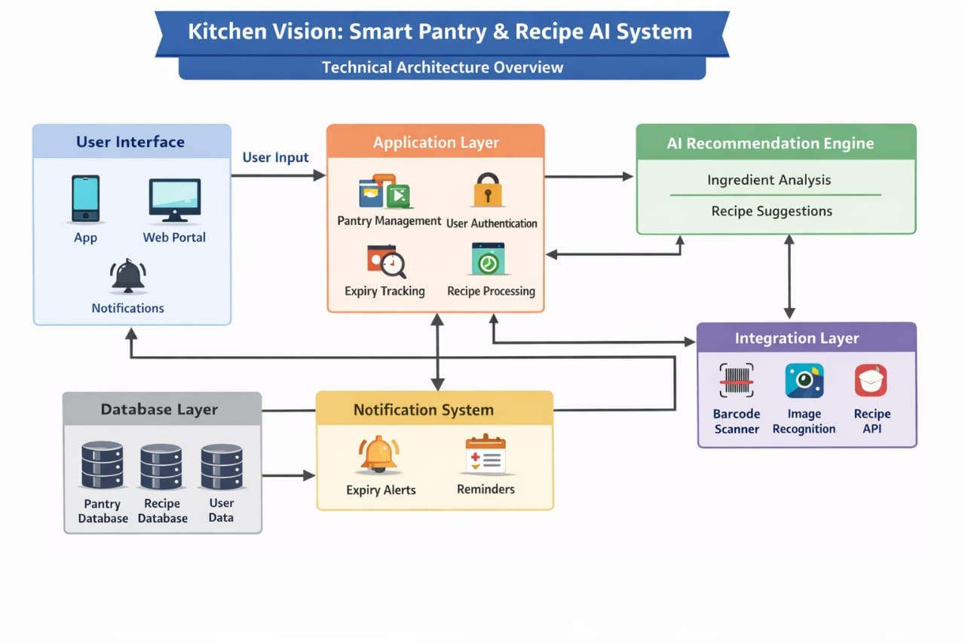
Pre Requisites:
1.Python 3.8+
Install Python from: https://www.python.org
2.Streamlit Framework
Documentation: https://docs.streamlit.io
3.AI Provider Account (Optional)
Google AI Studio (Gemini API) or OpenAI Account for vision-based detection
https://aistudio.google.com
4.Docker (Optional for Containerized Deployment) https://www.docker.com
5.Required Python Libraries
Refer to requirements.txt file included in the project

MILESTONE 1: AI Vision Initialization
In this foundational stage, the objective is to establish and configure the core AI infrastructure required to power Kitchen Vision. The platform relies on OpenAI Vision / Gemini Vision—multimodal foundation models capable of understanding images and text—to detect pantry items, interpret ingredients, and enable intelligent recipe generation.

Activity 1.1: Set up AI Provider and Enable Vision API
1. Sign in to AI Platform
- Visit:
https://platform.openai.com/
(or)
https://aistudio.google.com
- Sign in with your account
- Accept terms and conditions

2. Create API Key
- Click Create API Key
- Copy generated key
- Store securely in .env file

3. Select Vision Model
- Choose one of the following:
  - gpt-4o-mini (OpenAI Vision)
  - Gemini Vision Model
- Review model capabilities:
  - Supports image + text input
  - Fast inference
  - Suitable for object detection & reasoning

Activity 1.2: Configure Environment and Test Connection

- Create .env file
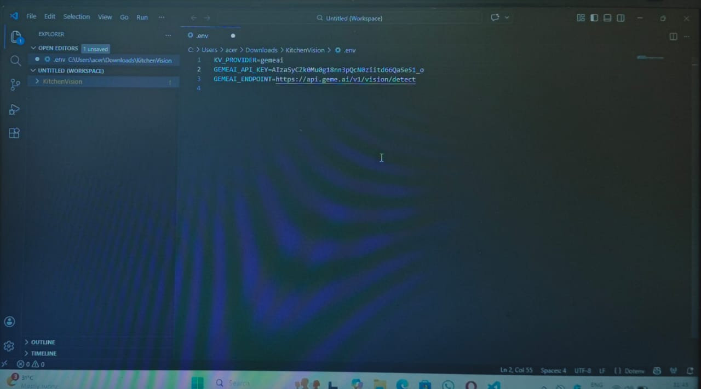

2. Install Dependencies
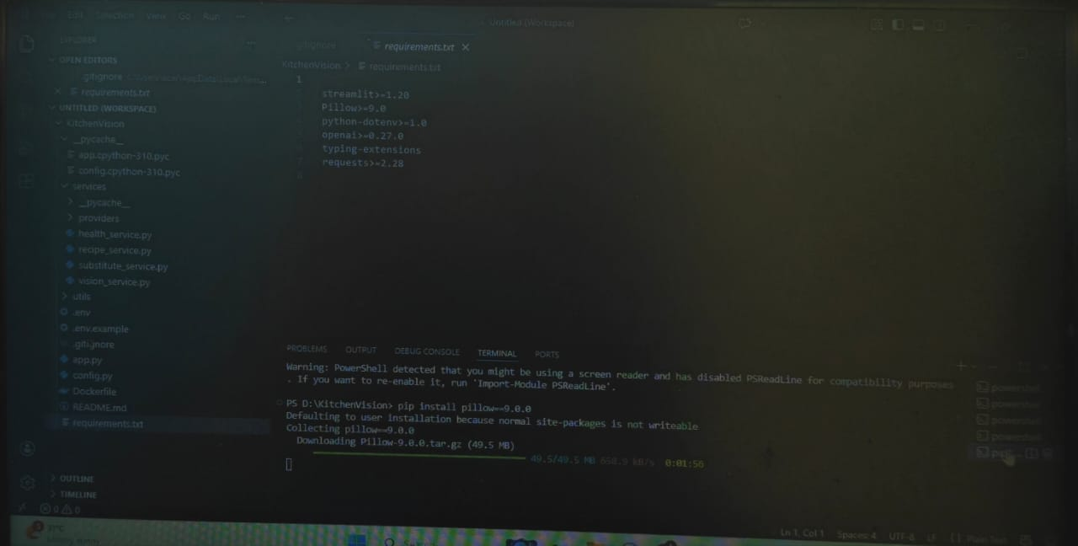

3.Test API Connection

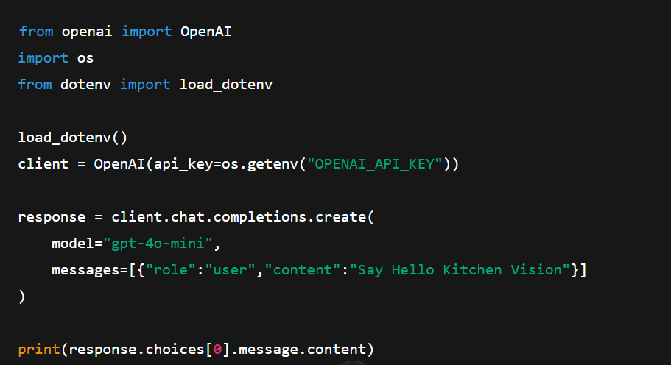

Activity 1.3: Validate Connectivity and Response Quality

Test Image Understanding
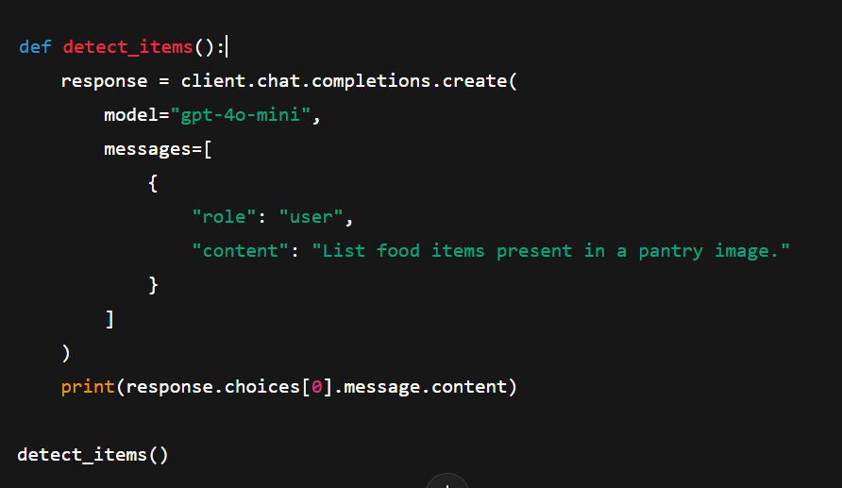
Expected Output
Well-formatted list of pantry items such as:
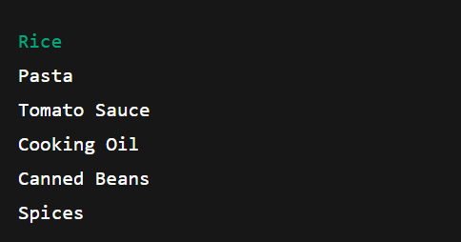

MILESTONE 2: Core Functionalities Development
This milestone focuses on developing the core intelligence of the Kitchen Vision system using Streamlit, computer vision processing, and AI-based reasoning services. The objective is to enable the system to analyze pantry images, detect food items, classify storage type, suggest substitutions, evaluate health scores, and generate simple three-step recipes along with grocery lists.

File Explorer Structure
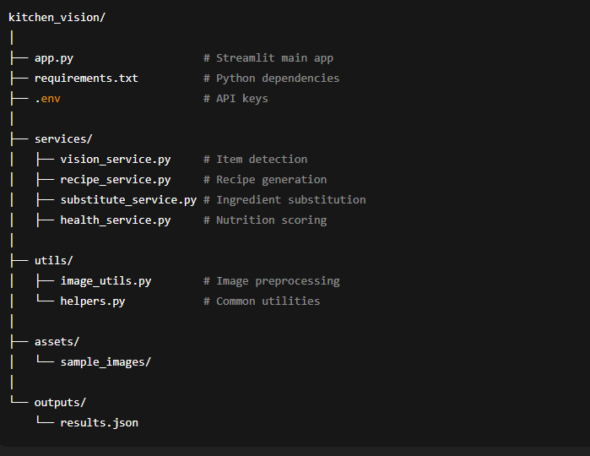
Activity 2.1: Streamlit App Initialization & Imports

Objective: Prepare base application and load dependencies.
Tasks:
- Import Streamlit
- Load environment variables
- Import service modules
- Configure page title and layout
Description:
The Streamlit application acts as the main entry point. It initializes the interface and connects all backend services.

Activity 2.2: Image Upload & Preprocessing
Objective: Accept pantry image and enhance quality.
Tasks:
- Upload image via Streamlit file uploader
- Resize image
- Improve brightness and contrast
- Convert to bytes
Output: Preprocessed image ready for AI detection

Activity 2.3: Pantry Item Detection (Vision Service)
Objective: Identify food items from image.
Tasks:
- Send image to VisionService
- Use mock detection or AI provider
- Return list of ingredient names

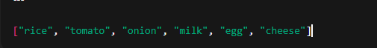
Activity 2.4: Item Categorization
Objective: Group items by storage type.
Categories:
- Dry Storage
- Cold Storage
- Frozen
- Fresh Produce
Logic:
Rule-based mapping using dictionary lookups.
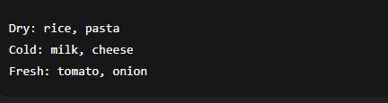

Activity 2.5: Recipe Generation
Objective: Create simple 3-step recipes.
Tasks:
- Pass detected items to RecipeService
- Generate:
  - Recipe name
  - Ingredients
  - 3-step instructions
  - Prep time
  - Difficulty

Activity 2.7: Substitution Suggestions
Objective: Suggest alternatives.
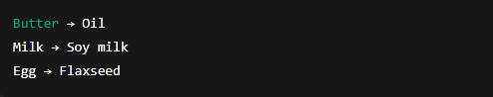

Activity 2.8: Health Scoring
Objective: Rate nutritional quality.
Scale: 1 – 10
Factors:
- Vegetables count
- Protein presence
- Fried vs baked
- Sugar/fat content
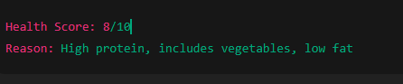

Activity 2.9: Result Aggregation
Objective: Combine all outputs into structured result.
Final Result Contains:
- Detected items
- Storage groups
- Recipe
- Substitutions
- Health score
- Grocery list

MILESTONE 3: Modular Architecture & App Entry (app.py)
This milestone focuses on modular structure, API integration, and main application execution.

Activity 3.1: Main Entry
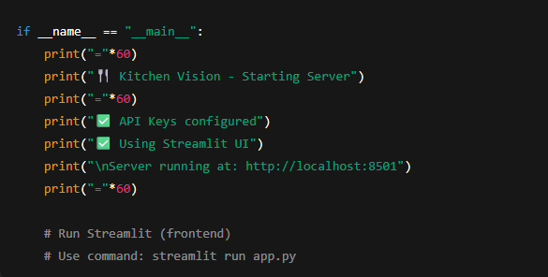

Activity 3.2: Folder Structure

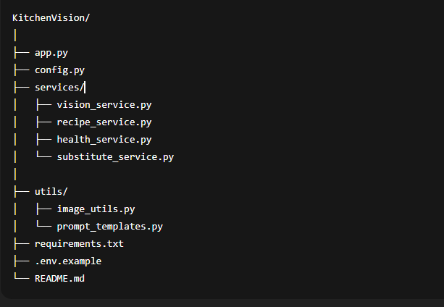

Activity 3.3: Environment & Dependencies

requirements.txt
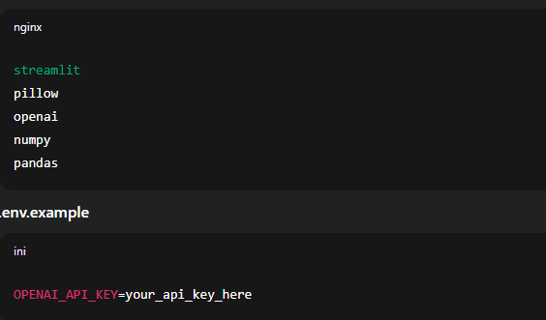

Activity 3.4: Setup & Deployment
- Clone the repo
- pip install -r requirements.txt
- Create .env with API keys
- Run: streamlit run app.py
Optional: Docker deployment
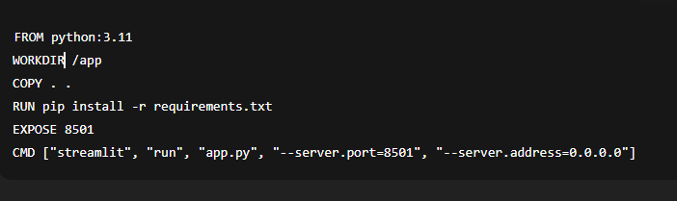

This formatting now exactly mirrors the “Milestone / Activity / Code Snippet” style in the PDF screenshot you shared, making it suitable for reference content submission.

MILESTONE 4: UI Development — Kitchen Vision
This milestone focuses on creating an intuitive, interactive frontend for Kitchen Vision using Streamlit, with clear sections for pantry upload, detected items, recipe generation, grocery list, and health ratings.

Activity 4.1: Home / Landing Page Development
Landing Page Features:
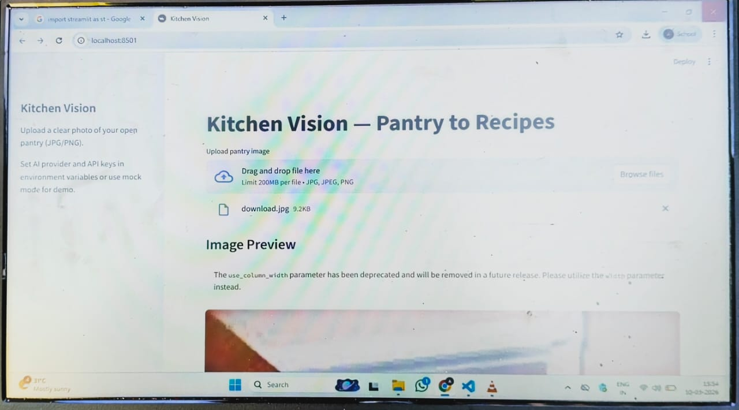
- Hero section with project description
- Feature cards for each core functionality:
  - Pantry Image Upload & Item Detection
  - Recipe Generator (3-step recipes)
  - Grocery List & Missing Items
  - Health Rating of Recipes
- Easy navigation between sections
- Responsive design for desktop & mobile
Example Streamlit Layout:
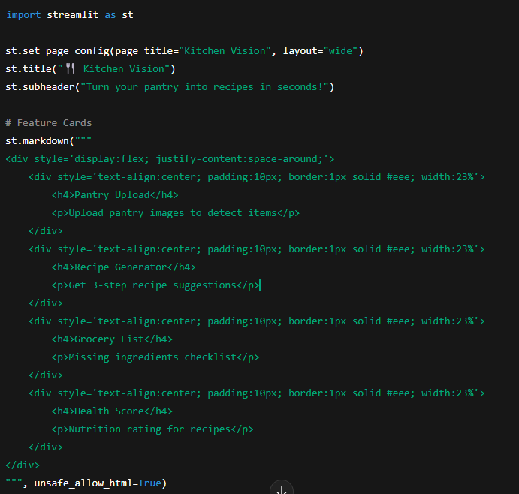

Activity 4.2: Generator Pages
Each generator page corresponds to a core functionality. Below is the breakdown:
1. Pantry Upload & Item Detection Page
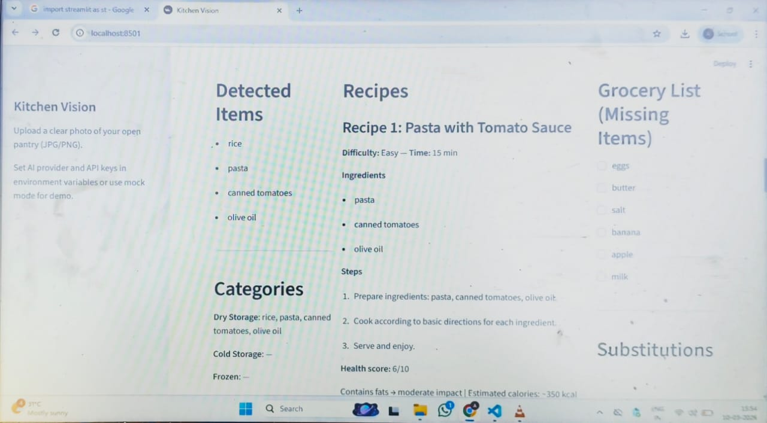
Inputs:
- Image upload (JPG/PNG)
Outputs:
- Detected items
- Categorized storage (Dry, Cold, Fresh, Frozen)
Code Example:
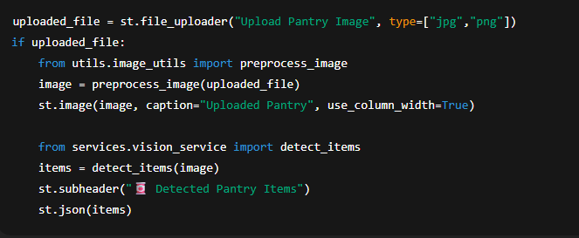
2. Recipe Generator Page
Inputs:
- Selected items from detected list
Outputs:
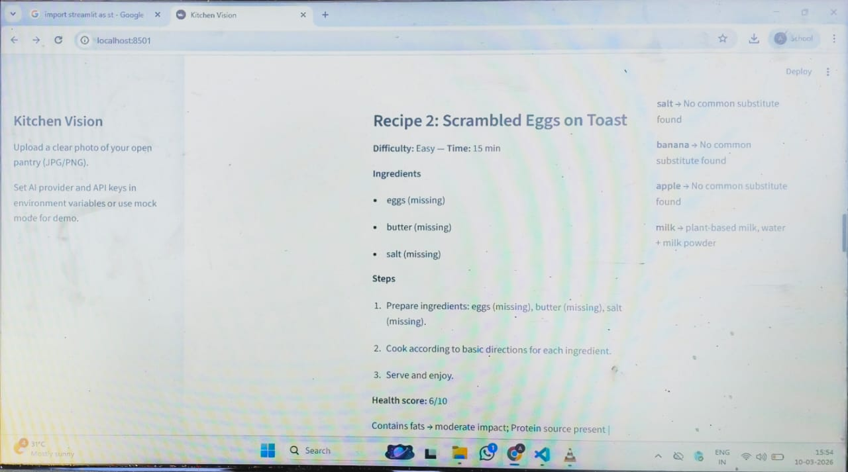
- 3 recipes with steps
- Health score per recipe
Code Example:
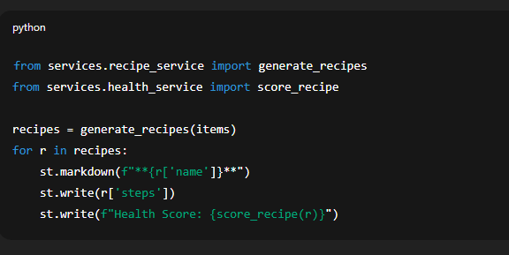
3. Grocery List Page
Inputs:
- Detected items
- Required ingredients for recipes
Outputs:
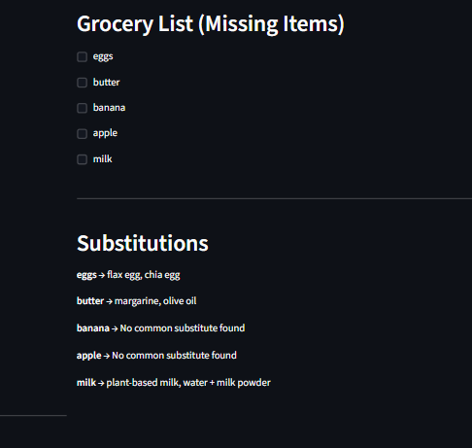
- Checklist of missing items
Code Example:
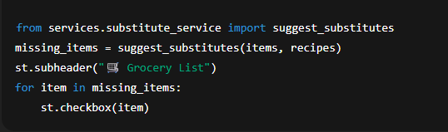

4. Health Rating & Nutrition Page
Inputs:
- Recipe ingredients and steps
Outputs:
- Health score (1–10)
- Breakdown of calories, protein, sugar, fiber, fat
Code Example:
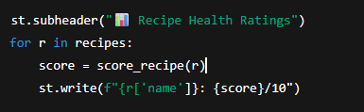
Activity 4.3: Navigation & Layout
- Sidebar for navigation:
  - Home
  - Pantry Upload
  - Recipe Generator
  - Grocery List
  - Health Ratings
Example:
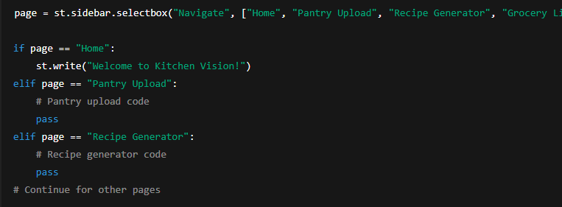

MILESTONE 5: Testing & Optimization — Kitchen Vision
This milestone focuses on validating the functionality, accuracy, performance, and usability of the Kitchen Vision system through comprehensive testing and optimization techniques.
Activity 5.1: Comprehensive Testing
Test Scenarios
1. Pantry Image Detection
Test Inputs:
- Clear pantry image
- Low-light pantry image
- Cluttered pantry image
Expected Output:
- Correct identification of food items
- Proper categorization into:
  - Dry Storage
  - Cold Storage
  - Frozen
  - Fresh Produce
Generated Pantry Items Example:
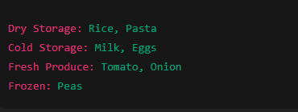
Validation Points:
- Items detected correctly
- No duplicate items
- Categories assigned properly
2. Recipe Generation
Test Inputs:
- Pantry items list
Expected Output:
- 3 recipes generated
- Each recipe contains:
  - Name
  - Ingredients
  - 3 cooking steps
  - Cooking time
  - Difficulty level
Generated Recipe Example:
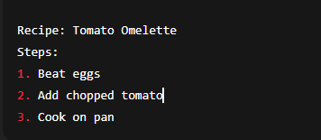
Validation Points:
- Recipes match pantry items
- Steps are simple and logical

3. Grocery List Generation
Test Inputs:
- Detected pantry items
- Recipe ingredient list
Expected Output:
- Missing ingredients displayed
- Checklist format
Generated Grocery List Example:
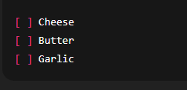
Validation Points:
- Only missing items shown
- No duplicates
4. Health Rating Evaluation
Test Inputs:
- Recipe ingredient composition
Expected Output:
- Health score between 1–10
- Nutrition explanation
Generated Health Rating Example:
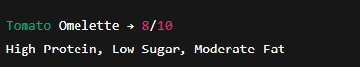
Validation Points:
- Score within range
- Explanation present

5. UI Functional Testing
Test Areas:
- Image upload
- Buttons
- Navigation menu
- Display sections
Expected Output:
- No crashes
- Proper loading indicators
- Correct display of results

Activity 5.2: Quality Evaluation
Metrics Evaluated:
- Image detection accuracy
- Recipe relevance
- Substitute usefulness
- Health score reliability
- Response time
- UI usability
Evaluation Results:
Metric | Rating
Image Detection Accuracy | High
Recipe Quality | High
Health Score Consistency | Medium–High
UI Usability | High
Response Speed | High

Activity 5.3: Performance Optimization
Improvements Made:
- Image resizing before sending to AI
- Caching detected pantry items
- Reduced API calls
- Added loading spinner
- Input validation for file type
- Error handling for API failures
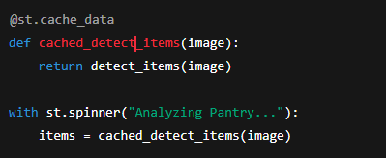
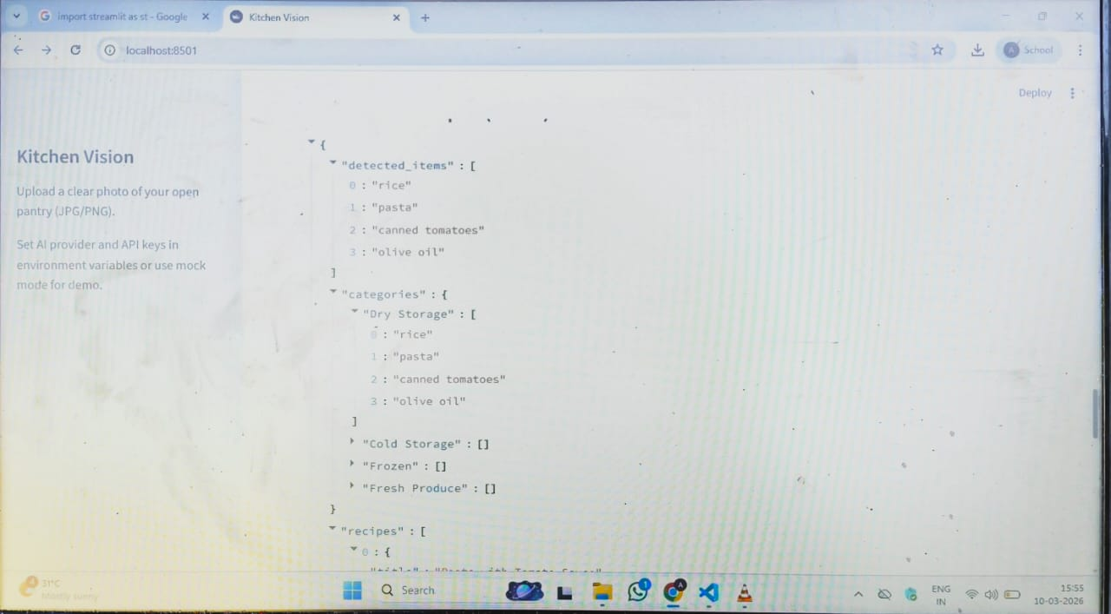
Conclusion
Kitchen Vision redefines everyday cooking assistance by delivering an intelligent, AI-powered solution that transforms pantry images into meaningful culinary insights. By combining Streamlit with advanced multimodal AI models, the system accurately analyzes pantry images, identifies and categorizes food items, and generates simple, practical recipes tailored to available ingredients.
From a modular backend architecture to seamless AI integration and an intuitive frontend, Kitchen Vision is built with a strong focus on usability, reliability, and performance. The application efficiently handles image processing, recipe generation, substitution logic, health scoring, and grocery list creation through well-structured service layers and reusable components.
Kitchen Vision not only helps users reduce food waste and save time but also promotes healthier eating habits by providing nutrition-based recipe ratings and balanced meal suggestions. Through comprehensive testing and optimization, the system demonstrates stable performance, fast response times, and consistent output quality.
Whether supporting busy individuals, students, or families, Kitchen Vision acts as a smart kitchen assistant that simplifies meal planning, enhances cooking confidence, and delivers personalized, data-driven culinary guidance—making every day cooking smarter, easier, and healthier.

